2025 CAR SHOW SPONSORSHIP OPPORTUNITIES:



LAMBORGHINI LEVEL - $5,000.00 includes:

- A table at the Annual Fiesta GALA on Saturday, May 3, 2025
- Website / Social Media / Brochure recognition
- Banner at Scholarship Gala on Saturday, May 3, 2025, and Fiesta/Car Show on Saturday, May 31, 2025.
- Powerpoint recognition at Scholarship Gala on Saturday, May 3, 2025.
- Loudspeaker recognition at Fiesta/Car Show on Saturday, May 31, 2025.


FERRARI LEVEL - $2,500.00 includes:

- Sponsor name on trophy
- 4 tickets and power point recognition at Banquet/GALA on Saturday, May 3, 2025.
- Website / URL recognition / FaceBook
- Banner at Scholarship Gala on Saturday, May 3, 2025, Fiesta/Car Show on Saturday, May 31, 2025.
- Powerpoint recognition at Scholarship Gala on Saturday, May 3, 2025.
- Loudspeaker recognition at Fiesta/Car Show on Saturday, May 31, 2025.

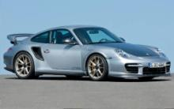
PORSCHE LEVEL - $1500.00 includes:

- Sponsor name on trophy
- Powerpoint recognition at Scholarship Gala on Saturday, May 3, 2025.

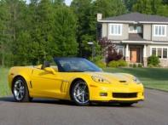

CORVETTE LEVEL - $1000.00 includes
- Social Media Recognition
- Powerpoint recognition at Scholarship Gala on Saturday, May 3, 2025.

